 **LAB REPORT**

**ICE-2204  
Signals and systems Sessional**

Department of

**INFORMATION AND COMMUNICATION ENGINEERING**

**PABNA UNIVERSITY OF SCIENCE AND TECHNOLOGY**

**Submission Date : 03-03-2025**

**Submitted To** :

Dr. Md. Imran Hossain

Associate Professor

Dept. of Information and Communication Engineering

**Submitted By** :

Al Kavy Joy

Roll : 220627

Session : 2021-22

Dept. of Information and Communication Engineering

# 

# Signals And Systems Lab Report

# Lab Report-01:

# Experiment Name:Discrete-Time Signals: (Impulse,Step,and Ramp Signals )

**Theory:**

• **Impulse Signal (δ[n])**: A discrete-time signal that is 1 at n = 0 and 0 elsewhere.

δ[n]={1if n=00if n≠0\delta[n] = \begin{cases} 1 & \text{if } n = 0 \\ 0 & \text{if } n \neq 0 \end{cases}δ[n]={10​if n=0if n=0​

• **Step Signal (u[n])**: A signal that is 0 for n < 0 and 1 for n ≥ 0.

u[n]={0if n<01if n≥0u[n] = \begin{cases} 0 & \text{if } n < 0 \\ 1 & \text{if } n \geq 0 \end{cases}u[n]={01​if n<0if n≥0​

• **Ramp Signal (r[n])**: A signal that increases linearly with n for n ≥ 0 and is 0 for n < 0.

r[n]={nif n≥00if n<0r[n] = \begin{cases} n & \text{if } n \geq 0 \\ 0 & \text{if } n < 0 \end{cases}r[n]={n0​if n≥0if n<0​

**Source Code:**

import numpy as np

import matplotlib.pyplot as plt

# Define the range

n = np.arange(-10, 11)

def impulse_signal(n):

return np.where(n == 0, 1, 0)

def step_signal(n):

return np.where(n >= 0, 1, 0)

def ramp_signal(n):

return np.where(n >= 0, n, 0)

# Generate signals

impulse = impulse_signal(n)

step = step_signal(n)

ramp = ramp_signal(n)

# Plot signals

plt.figure(figsize=(12, 4))

plt.subplot(1, 3, 1)

plt.stem(n, impulse)

plt.title("Impulse Signal")

plt.xlabel("n")

plt.ylabel("Amplitude")

plt.grid()

plt.subplot(1, 3, 2)

plt.stem(n, step)

plt.title("Step Signal")

plt.xlabel("n")

plt.ylabel("Amplitude")

plt.grid()

plt.subplot(1, 3, 3)

plt.stem(n, ramp)

plt.title("Ramp Signal")

plt.xlabel("n")

plt.ylabel("Amplitude")

plt.grid()

plt.tight_layout()

plt.show()

Output :

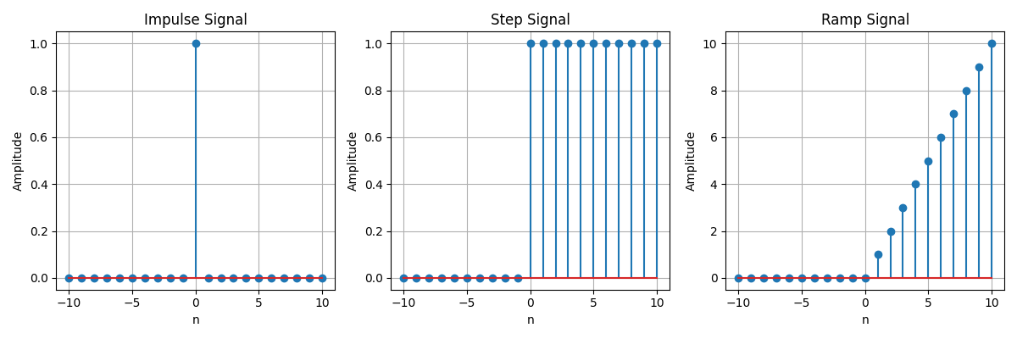

**Purpose :**

The purpose of this lab is to understand and implement basic signal operations such as addition, shifting, folding, and multiplication using Python. These operations are fundamental in digital signal processing (DSP) and help manipulate signals for analysis and processing.

# Lab Report-02:

# Experiment Name: Signal Operations: Addition, Multiplication, Scaling, Shifting, and Folding

Theory:

Signal processing involves manipulating signals to modify or enhance them. Common operations include:

* **Addition:** Combining two signals element-wise.
* **Multiplication:** Element-wise product of two signals.
* **Scaling:** Multiplying a signal by a constant to change its amplitude.
* **Shifting:** Translating a signal along the time axis.
* **Folding:** Reversing the signal with respect to time.

These operations are essential in fields like communications, audio processing, and control systems..

Source Code:

import numpy as np

import matplotlib.pyplot as plt

def signal_addition(x1, x2):

return x1 + x2

def signal_multiplication(x1, x2):

return x1 * x2

def signal_scaling(x, alpha):

return alpha * x

def signal_shifting(n, shift):

return n + shift

def signal_folding(x):

return np.flip(x)

n = np.array([-2, -1, 0, 1, 2])

x1 = np.array([1, 2, 3, 4, 5])

x2 = np.array([5, 4, 3, 2, 1])

added_signal = signal_addition(x1, x2)

multiplied_signal = signal_multiplication(x1, x2)

scaled_signal = signal_scaling(x1, 2)

shifted_signal1 = signal_shifting(n, -2)

shifted_signal2 = signal_shifting(n, 2)

folded_signal = signal_folding(x1)

plt.figure(figsize=(12, 10))

plt.subplot(4, 2, 1)

plt.stem(n, x1)

plt.xlabel("Time")

plt.ylabel("Amplitude")

plt.title("Original Signal x1")

plt.grid()

plt.subplot(4, 2, 2)

plt.stem(n, x2)

plt.xlabel("Time ")

plt.ylabel("Amplitude")

plt.title("Original Signal x2")

plt.grid()

plt.subplot(4, 2, 3)

plt.stem(n, added_signal)

plt.xlabel("Time")

plt.ylabel("Amplitude")

plt.title("Signal Addition")

plt.grid()

plt.subplot(4, 2, 4)

plt.stem(n, multiplied_signal)

plt.xlabel("Time")

plt.ylabel("Amplitude")

plt.title("Signal Multiplication")

plt.grid()

plt.subplot(4, 2, 5)

plt.stem(n, scaled_signal)

plt.xlabel("Time")

plt.ylabel("Amplitude")

plt.title("Scaled Signal (x1 * 2)")

plt.grid()

plt.subplot(4, 2, 6)

plt.stem(shifted_signal1, x1)

plt.xlabel("Time")

plt.ylabel("Amplitude")

plt.title("Shifted Signal (Shift = -2)")

plt.grid()

plt.subplot(4, 2, 7)

plt.stem(shifted_signal2, x1)

plt.xlabel("Time")

plt.ylabel("Amplitude")

plt.title("Shifted Signal (Shift = +2)")

plt.grid()

plt.subplot(4, 2, 8)

plt.stem(n, folded_signal)

plt.xlabel("Time")

plt.ylabel("Amplitude")

plt.title("Folded Signal (x1)")

plt.grid()

plt.tight_layout()

plt.show()

Output :

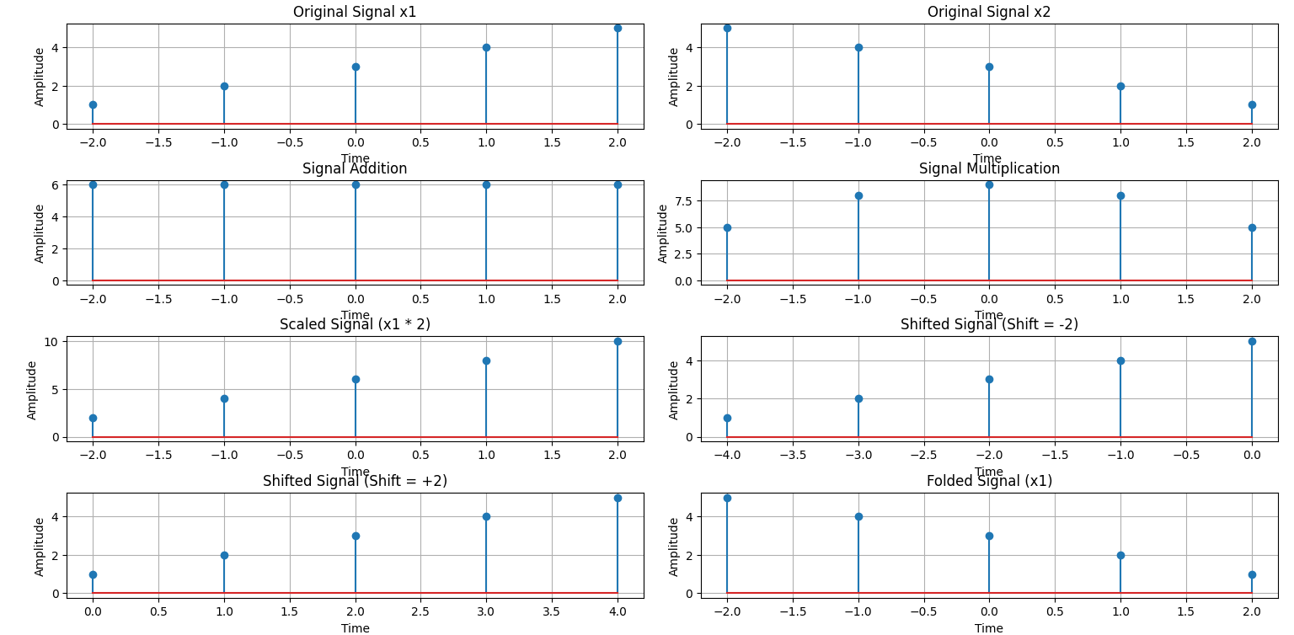

## **Purpose :**

The purpose of this lab is to understand and implement the concept of convolution in digital signal processing (DSP) using Python. Convolution is a fundamental operation used in systems analysis, filtering, and feature extraction.

# Lab Report-03:

# Experiment Name: Autocorrelation and Cross-Correlation Analysis of Signals with Noise

Theory:

1. Correlation is a mathematical operation that measures the similarity between two signals as a function of time-lag applied to one of them. There are two main types of correlation:

* **Autocorrelation**: Measures the similarity of a signal with a delayed version of itself. It is useful for detecting repeating patterns and periodicity in signals. where is the autocorrelation function and represents the lag.

**Cross-Correlation**: Measures the similarity between two different signals as a function of time lag. It is useful for detecting the time delay between two signals. where is the cross-correlation function

Source Code:

import numpy as np

import matplotlib.pyplot as plt

from scipy.signal import correlate, correlation_lags

def compute_autocorrelation(signal):

auto_corr = correlate(signal, signal, mode='full', method='auto')

lags = correlation_lags(len(signal), len(signal), mode='full')

return auto_corr, lags

def compute_cross_correlation(signal1, signal2):

cross_corr = correlate(signal1, signal2, mode='full', method='auto')

lags = correlation_lags(len(signal1), len(signal2), mode='full')

return cross_corr, lags

fs = 1000 # Sampling frequency in Hz

t = np.linspace(0, 1, fs, endpoint=False) # Time vector

freq = 5 # Frequency of the sine wave

sin_signal = np.sin(2 * np.pi * freq * t)

auto_corr, lags_auto = compute_autocorrelation(sin_signal)

signal1 = sin_signal

signal2 = np.roll(signal1, 100)

cross_corr, lags_cross = compute_cross_correlation(signal1, signal2)

noise = np.random.normal(0, 0.5, fs)

noisy_signal = signal1 + noise

cross_corr_noise, lags_noise = compute_cross_correlation(signal1, noisy_signal)

plt.figure(figsize=(12, 12))

plt.subplot(3, 1, 1)

plt.plot(lags_auto, auto_corr)

plt.title("Autocorrelation of a Sinusoidal Signal")

plt.xlabel("Lag")

plt.ylabel("Autocorrelation")

plt.grid()

plt.subplot(3, 1, 2)

plt.plot(lags_cross, cross_corr)

plt.title("Cross-Correlation between Two Signals")

plt.xlabel("Lag")

plt.ylabel("Cross-Correlation")

plt.grid()

plt.subplot(3, 1, 3)

plt.plot(lags_noise, cross_corr_noise)

plt.title("Cross-Correlation with Noisy Signal")

plt.xlabel("Lag")

plt.ylabel("Cross-Correlation")

plt.grid()

plt.tight_layout()

plt.show()

Output:

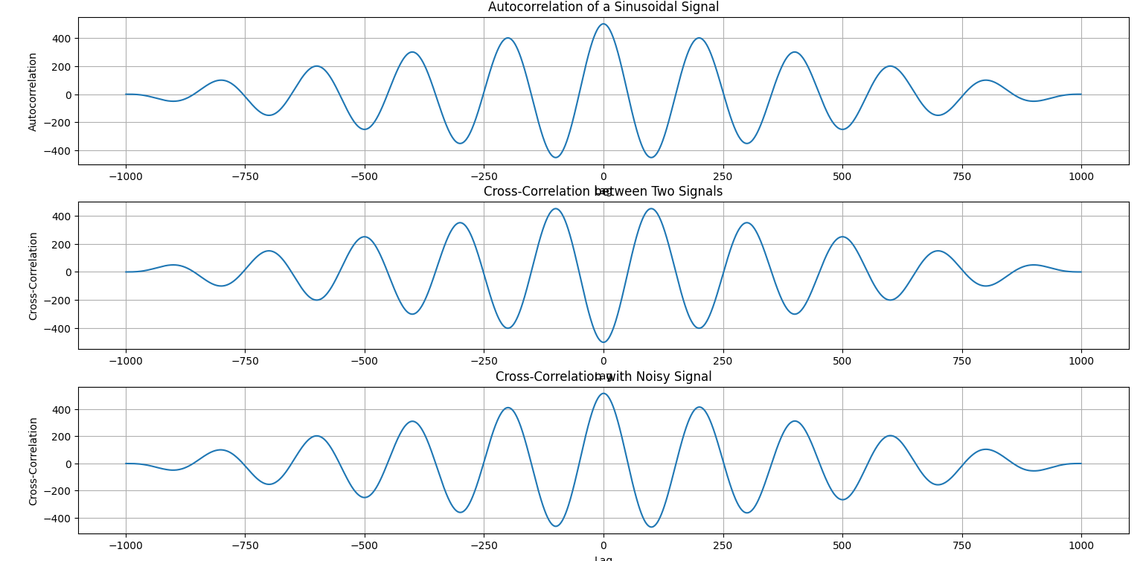

## **Purpose :**

The purpose of this lab is to understand and implement the concept of correlation in digital signal processing (DSP) using Python. Correlation measures the similarity between two signals as a function of the time-lag applied to one of them. It is widely used in pattern recognition, signal detection, and feature matching

# Lab Report-04:

# Experiment Name: Convolution Analysis of Signals: Autoconvolution, Shifted Signals, and Noise Effects

Theory:

Convolution is a mathematical operation that combines two signals to produce a third, showing their overlap as a function of time shift. Key concepts include:

* **Autoconvolution**: Convolving a signal with itself to detect patterns and periodicity.
* **Convolution with Shifted Signals**: Analyzing the similarity between a signal and its shifted version.
* **Convolution with Noisy Signals**: Studying the effect of noise on a signal through convolution.

Source Code:

import numpy as np

import matplotlib.pyplot as plt

from scipy.signal import convolve

def compute_convolution(signal1, signal2):

conv_result = convolve(signal1, signal2, mode='full', method='auto')

return conv_result

fs = 1000 # Sampling frequency in Hz

t = np.linspace(0, 1, fs, endpoint=False) # Time vector

freq = 5 # Frequency of the sine wave

sin_signal = np.sin(2 * np.pi * freq * t)

conv_auto = compute_convolution(sin_signal, sin_signal)

signal1 = sin_signal

signal2 = np.roll(signal1, 100)

conv_shifted = compute_convolution(signal1, signal2)

noise = np.random.normal(0, 0.5, fs)

noisy_signal = signal1 + noise

conv_noisy = compute_convolution(signal1, noisy_signal)

plt.figure(figsize=(12, 12))

plt.subplot(3, 1, 1)

plt.plot(conv_auto)

plt.title("Autoconvolution of a Sinusoidal Signal")

plt.xlabel("Samples")

plt.ylabel("Convolution Output")

plt.grid()

plt.subplot(3, 1, 2)

plt.plot(conv_shifted)

plt.title("Convolution between Signal and Shifted Version")

plt.xlabel("Samples")

plt.ylabel("Convolution Output")

plt.grid()

plt.subplot(3, 1, 3)

plt.plot(conv_noisy)

plt.title("Convolution with Noisy Signal")

plt.xlabel("Samples")

plt.ylabel("Convolution Output")

plt.grid()

plt.tight_layout()

plt.show()

Output :

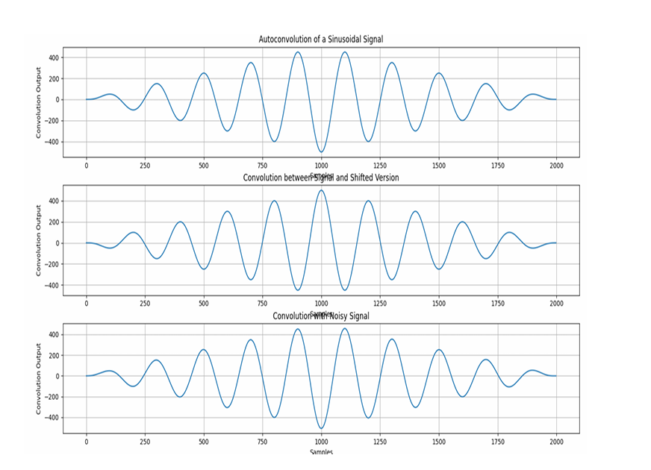

## **Purpose :**

The purpose of this lab is to explore and analyze different types of signal sequences using Python. By understanding these fundamental sequences—including unit impulse, unit step, ramp, exponential, and sinusoidal signals—students will gain a solid foundation in digital signal processing (DSP). These sequences serve as building blocks for more advanced signal analysis, system response evaluation, and practical applications in communications, control systems, and electronics.

# Lab Report- 05:

# Experiment Name - Heart Rate Estimation from PPG Signal Using Bandpass Filtering and Peak Detection

Theory:

This code processes a PPG signal to estimate heart rate by:

1. **Bandpass Filtering**: Removes noise and retains frequencies relevant to the heart rate (0.5 Hz to 5 Hz).
2. **Peak Detection**: Identifies peaks in the signal corresponding to heartbeats.
3. **Heart Rate Estimation**: Calculates the heart rate by averaging the time intervals between peaks (R-R intervals).
4. **Normalization**: Scales the signal for easier peak detection.

Source Code:

import numpy as np

import scipy.signal as signal

import matplotlib.pyplot as plt

def bandpass_filter(data, fs=100):

b, a = signal.butter(4, [0.5 / (0.5 * fs), 5.0 / (0.5 * fs)], btype='band')

return signal.filtfilt(b, a, data)

def detect_peaks(signal_data):

return signal.find_peaks(signal_data, distance=50)[0]

def extract_heart_rate(peaks, fs=100):

if len(peaks) < 2:

return 0

rr_intervals = np.diff(peaks) / fs

return 60 / np.mean(rr_intervals)

# Generate synthetic PPG signal

fs = 100

t = np.linspace(0, 10, fs * 10)

sine_signal = np.sin(2 * np.pi * 1.2 * t)

noise_signal = 0.1 * np.random.normal(0, 1, len(t))

ppg_signal = sine_signal + noise_signal

# Process PPG signal

filtered_signal = bandpass_filter(ppg_signal, fs)

normalized_signal = (filtered_signal - np.min(filtered_signal)) / (np.max(filtered_signal) -

np.min(filtered_signal))

peaks = detect_peaks(normalized_signal)

heart_rate = extract_heart_rate(peaks, fs)

# Print results

print("Filtered Signal (first 10 values):", filtered_signal[:10])

print("Detected Peaks (first 10 indices):", peaks[:10])

print(f"Estimated Heart Rate: {heart_rate:.2f} BPM")

# Plot results

plt.figure(figsize=(12, 9))

plt.subplot(3, 2, 1)

plt.plot(t, sine_signal, label='Raw Sine Signal')

plt.xlabel("Time")

plt.ylabel("Amplitude")

plt.legend()

plt.subplot(3, 2, 2)

plt.plot(t, noise_signal, label='Raw Noise Signal')

plt.xlabel("Time")

plt.ylabel("Amplitude")

plt.legend()

plt.subplot(3, 2, 3)

plt.plot(t, ppg_signal, label='Raw PPG Signal')

plt.xlabel("Time")

plt.ylabel("Amplitude")

plt.legend()

plt.subplot(3, 2, 4)

plt.plot(t, filtered_signal, label='Filtered PPG Signal')

plt.xlabel("Time")

plt.ylabel("Amplitude")

plt.legend()

plt.subplot(3, 2, 5)

plt.plot(t, normalized_signal, label='Normalized PPG Signal')

plt.xlabel("Time")

plt.ylabel("Amplitude")

plt.legend()

plt.subplot(3, 2, 6)

plt.plot(t, normalized_signal,label=f'PPG with Detected Peaks')

plt.plot(t[peaks], normalized_signal[peaks],'ro', label='Detected Peaks')

plt.xlabel("Time")

plt.ylabel("Amplitude")

plt.legend()

plt.tight_layout()

plt.show()

Output:

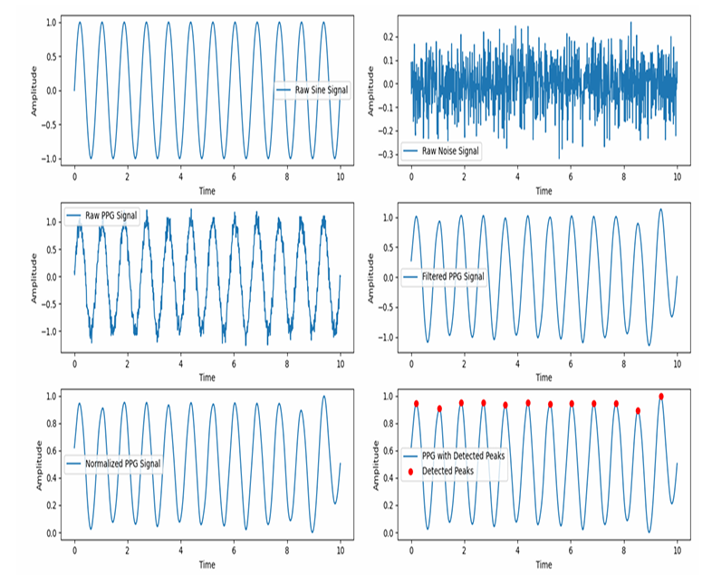

**Purpose :**

The purpose of this lab is to analyze Photoplethysmogram (PPG) signals using Python, focusing on signal filtering, feature extraction, and peak detection. PPG signals are widely used in healthcare for monitoring heart rate, blood oxygen levels, and assessing cardiovascular health. The goal is to demonstrate how to preprocess PPG data, extract relevant features, and accurately detect peaks corresponding to heartbeats.

# Lab Report- 06:

# Experiment Name: Discrete Fourier Transform (DFT) and Inverse DFT (IDFT) of a Signal

Theory:

* **DFT (Discrete Fourier Transform)** converts a time-domain signal into its frequency components, revealing the signal's frequency content.
* **IDFT (Inverse Discrete Fourier Transform)** reconstructs the original time-domain signal from its frequency components.

These transforms are essential in signal processing for tasks like spectrum analysis and signal reconstruction.

Source Code:

mport numpy as np

import matplotlib.pyplot as plt

# Input sequence and N

x = [1,1,1,1]

N= 4

x = np.pad(x, (0, N - len(x)), mode='constant')

# DFT computation

X = np.fft.fft(x, N)

# IDFT computation (Inverse DFT)

x_reconstructed = np.fft.ifft(X)

# Print the DFT and IDFT values

print("DFT values:", X)

print("Reconstructed IDFT values:", x_reconstructed.real)

# Plot the input signal

plt.figure(figsize=(10, 6))

plt.subplot(3, 1, 1)

plt.stem(range(len(x)), x)

plt.title('Input Signal x(n)')

plt.xlabel('n')

plt.ylabel('x(n)')

plt.grid()

# Plot the magnitude of DFT

plt.subplot(3, 1, 2)

plt.stem(range(N), np.abs(X))

plt.title('DFT Magnitude |X(k)|')

plt.xlabel('k')

plt.ylabel('|X(k)|')

plt.grid()

# Plot the IDFT signal

plt.subplot(3, 1, 3)

plt.stem(range(N), x_reconstructed.real)

plt.title('Reconstructed Signal x(n) from IDFT')

plt.xlabel('n')

plt.ylabel('x(n)')

plt.grid()

plt.tight_layout()

plt.show()

Output:

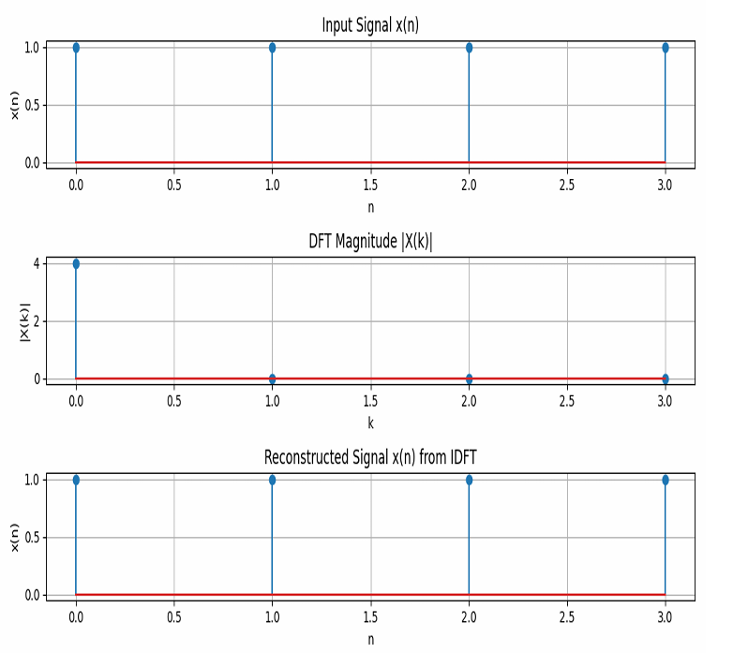

**Purpose:**

The purpose of this experiment is to understand the concept of the Fourier Transform, explore how it transforms a time-domain signal into its frequency-domain representation, and implement the Fourier Transform using Python. The experiment aims to help visualize how the Fourier Transform breaks down complex signals into simpler sine and cosine components

# Lab Report-07:

# Experiment Name: Fourier Series Approximation of a Square Wave

Theory:

The **Fourier Series** is a mathematical tool used to express a periodic function as a sum of sine and cosine functions. It helps to approximate complex periodic signals using simpler sinusoidal components.

1. **Square Wave:**
   * A square wave is a periodic waveform that alternates between two levels, typically +1 and -1. It is a non-sinusoidal waveform, often used in digital signals and communications.
2. **Fourier Series Approximation:**
   * The Fourier series allows us to approximate any periodic function (such as a square wave) as a sum of sinusoidal functions (sines and cosines). For a square wave, the Fourier series consists only of odd harmonics (sine terms with odd multiples of the fundamental frequency).
   * As the number of terms in the Fourier series increases, the approximation becomes closer to the original square wave, exhibiting sharp transitions between the levels.

Source Code:

import numpy as np

import matplotlib.pyplot as plt

def fourier_series(x, terms):

if terms < 1:

raise ValueError("Number of terms must be at least 1")

result = x - x

for n in range(1, terms + 1, 2):

result += (4 / (np.pi * n)) * np.sin(n * x)

return result

# Define the original square wave function

def square_wave(x):

return np.where(np.sin(x) >= 0, 1, -1)

# Generate x values

t = np.linspace(-np.pi, np.pi, 400)

# Plot different approximations

plt.figure(figsize=(8, 6))

# Plot the original square wave

plt.plot(t, square_wave(t), label='Original Square Wave', linestyle='--', color='black')

for terms in [1, 3, 5, 9]:

plt.plot(t, fourier_series(t, terms), label=f'{terms} terms')

plt.axhline(0, color='black', linewidth=0.5, linestyle='--')

plt.title('Fourier Series Approximation of a Square Wave')

plt.xlabel('Time')

plt.ylabel('Amplitude')

plt.legend()

plt.grid()

plt.show()

Output:

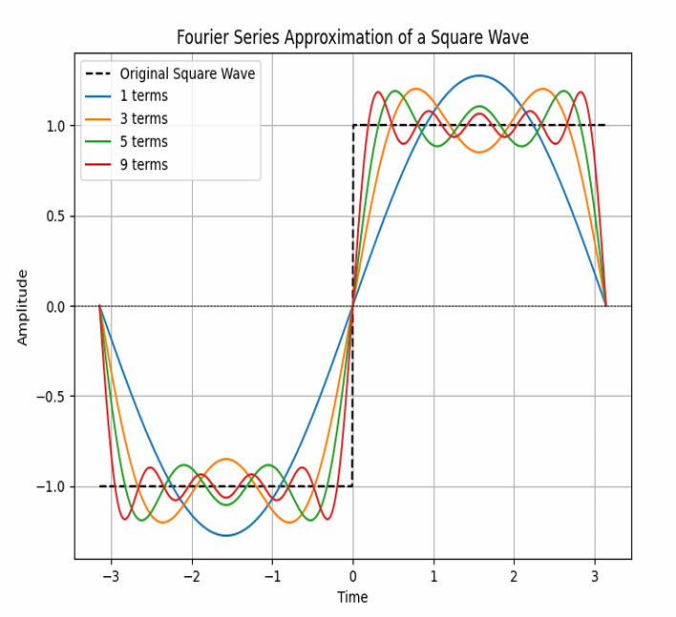

**Purpose:**

The purpose of this experiment is to understand the concept of the Fourier Transform, explore how it transforms a time-domain signal into its frequency-domain representation, and implement the Fourier Transform using Python. The experiment aims to help visualize how the Fourier Transform breaks down complex signals into simpler sine and cosine components

# Lab Report-08:

# Experiment Name: Visualizing the real, phase, and magnitude components of the sinc function.

Theory:

e **sinc function** is defined as:

sinc(x)=sin⁡(πx)πx\text{sinc}(x) = \frac{\sin(\pi x)}{\pi x}sinc(x)=πxsin(πx)​

However, in this case, the function is scaled as sinc(4t)\text{sinc}(4t)sinc(4t), which is a normalized version of the sinc function.

1. **Real Part**: The real part of a complex signal is the actual value of the signal at any given time.
2. **Phase Part**: The phase represents the shift of the signal in time. It can be obtained using the **angle** of the signal, angle(x)\text{angle}(x)angle(x), which gives the phase of the complex values.
3. **Magnitude Part**: The magnitude represents the absolute value of the signal at any point in time. It provides information about the amplitude of the signal.

Source Code:

import numpy as np

import matplotlib.pyplot as plt

t = np.arange(-2, 2.01, 0.01)

x = 4 * np.sinc(4 * t)

# Plot real part

plt.figure(figsize=(10, 6))

plt.subplot(3, 1, 1)

plt.plot(t, x)

plt.xlabel('Time')

plt.ylabel('Amplitude')

plt.title('Real Part')

plt.grid()

# Plot phase part

plt.subplot(3, 1, 2)

plt.plot(t, np.angle(x))

plt.xlabel('Time')

plt.ylabel('Amplitude')

plt.title('Phase Part')

plt.grid()

# Plot magnitude part

plt.subplot(3, 1, 3)

plt.plot(t, np.abs(x))

plt.ylabel('Amplitude')

plt.title('Magnitude Part')

plt.grid()

plt.tight_layout()

plt.show()

Output:

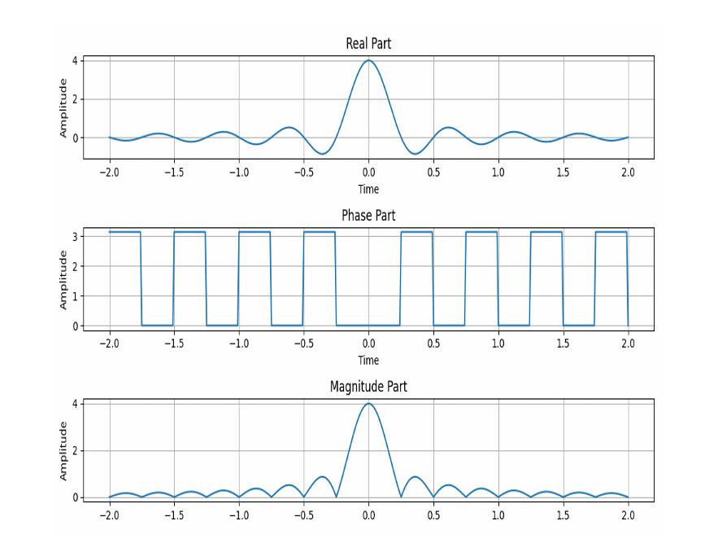

### **Purpose:**

The purpose of this experiment is to understand the concept of the Discrete Fourier Transform (DFT), its mathematical formulation, and its practical implementation using Python. The experiment aims to analyze how DFT converts a discrete time-domain signal into its frequency-domain representation and visualize the results.